**-: Assessment of Module 4 :-**

● **Write SQL query to solve the problem given below**

Consider a scenario in which you have to create a table called Nobel_win where you have given the information about the entity who has achieved nobel prize in a particular subject all over the world.

Over here the table Nobel_win will contain attributes like year, subject, winner, country and category

You need to use the sql commands to create the table given and to solve the problem given below.

Eg :

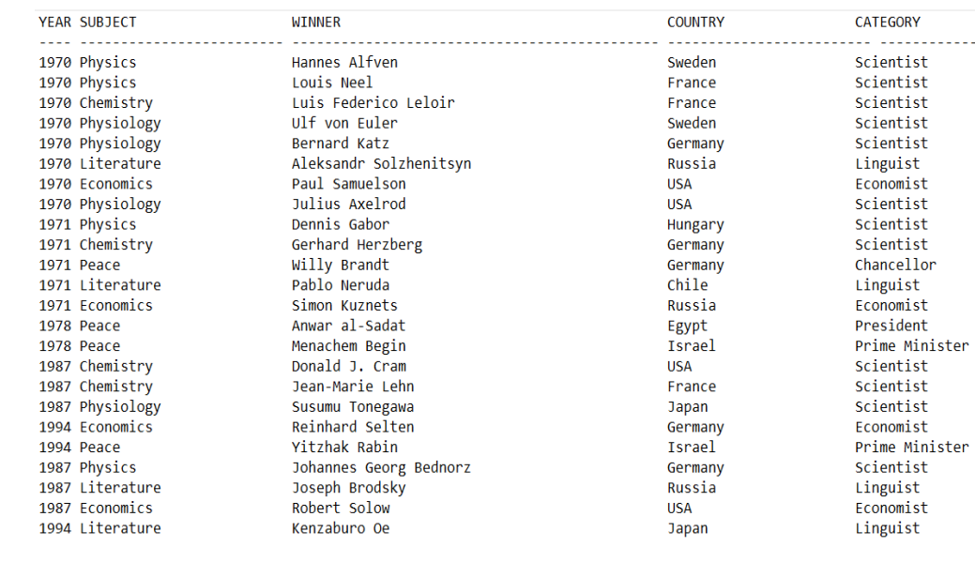

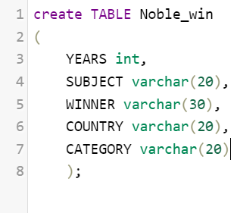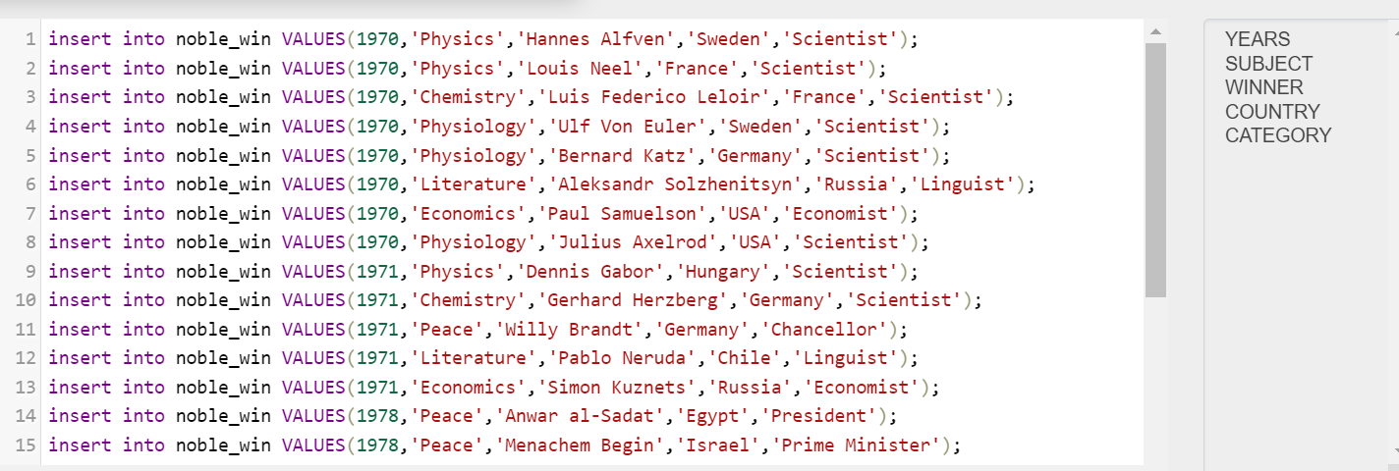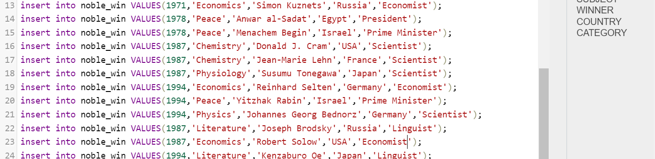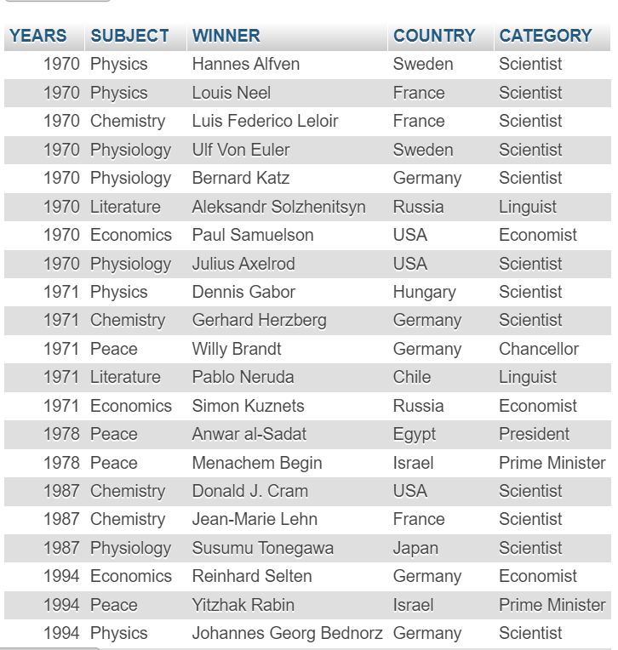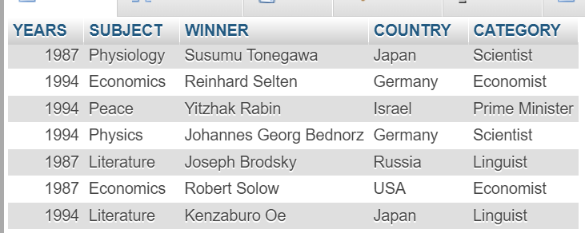

Now make sure to solve the following query :

● Write sql query to find the nobel prize winners of the year 1970. Return year,subject and winner

Answer :- [SELECT](http://localhost/phpmyadmin/url.php?url=https://dev.mysql.com/doc/refman/8.0/en/select.html) YEARS, SUBJECT,WINNER from noble_win where YEARS=1970;

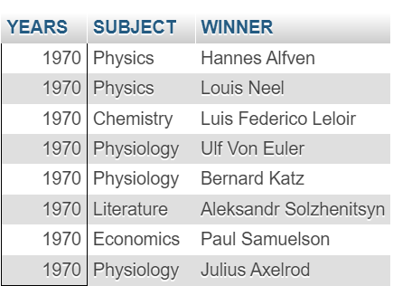

● Write sql query to find the nobel prize winners in chemistry between the years 1965 and 1975. Begin and end values are included Return year, subject, winner and country

Answer :- [SELECT](http://localhost/phpmyadmin/url.php?url=https://dev.mysql.com/doc/refman/8.0/en/select.html) YEARS, SUBJECT, WINNER, COUNTRY from noble_win where SUBJECT='Chemistry'[AND](http://localhost/phpmyadmin/url.php?url=https://dev.mysql.com/doc/refman/8.0/en/logical-operators.html%23operator_and) YEARS BETWEEN 1965 [AND](http://localhost/phpmyadmin/url.php?url=https://dev.mysql.com/doc/refman/8.0/en/logical-operators.html%23operator_and) 1975;

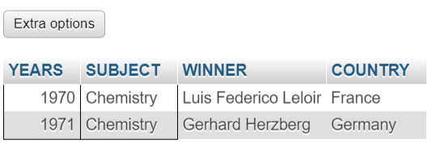

● Write sql query to retrieve the details of the winners whose first name matches with the string ‘Louis’. Return year, subject, winner, country

Answer :- [SELECT](http://localhost/phpmyadmin/url.php?url=https://dev.mysql.com/doc/refman/8.0/en/select.html) YEARS, SUBJECT, WINNER,COUNTRY from noble_win where WINNER [LIKE](http://localhost/phpmyadmin/url.php?url=https://dev.mysql.com/doc/refman/8.0/en/string-comparison-functions.html%23operator_like) 'Louis%';



● Write sql query to find Nobel prize winners for the subject that does not begin with the letter ‘P’. Order the result by year, descending and winner in ascending

Answer :- [SELECT](http://localhost/phpmyadmin/url.php?url=https://dev.mysql.com/doc/refman/8.0/en/select.html) * from noble_win WHERE SUBJECT [NOT](http://localhost/phpmyadmin/url.php?url=https://dev.mysql.com/doc/refman/8.0/en/logical-operators.html%23operator_not) [LIKE](http://localhost/phpmyadmin/url.php?url=https://dev.mysql.com/doc/refman/8.0/en/string-comparison-functions.html%23operator_like) 'P%' ORDER BY WINNER,YEARS DESC;

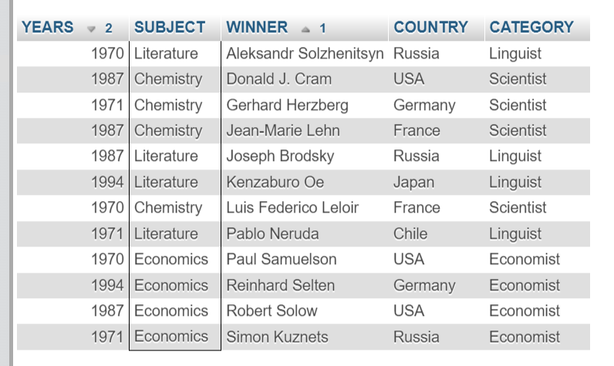

● Write sql query to find the details of 1970 Nobel prize winners. Order the result by subject, ascending except for ‘Chemistry’ and ‘Economics’ which will come at the end of the result set. Return year, subject, winner , country and category.

Answer :- [SELECT](http://localhost/phpmyadmin/url.php?url=https://dev.mysql.com/doc/refman/8.0/en/select.html) * FROM noble_win where YEARS=1970 order by SUBJECT [IN](http://localhost/phpmyadmin/url.php?url=https://dev.mysql.com/doc/refman/8.0/en/comparison-operators.html%23function_in)('Chemistry','Economics');

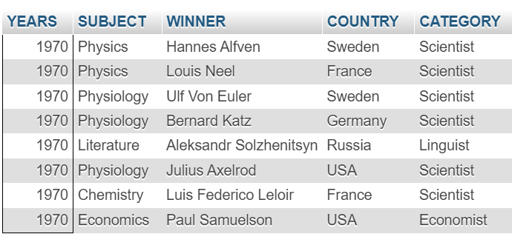

**Submitted By :-** **Ansari Amanhusain K.**